Fayette County Public Schools
Summary of Safety Drills

As part of the school system’s emergency planning, all of our schools practice emergency procedure by conducting periodic drills. The purpose of these drills is to train and rehearse our students and staff in the proper procedures. These drills follow the guidelines from the U.S. Department of Homeland Security, the Georgia Emergency Management Agency and our local Emergency Management Agency.
Fire Drill: In preparation for a fire in the building or on the premises requiring the evacuation of the building. These drills are conducted twice during the first 30 days of school and then monthly, except during the months when Severe Weather Drills are conducted. The fire alarm is activated in order for the school to recognize the alarm. Teachers lead their classes to designated safe locations outside of the school building. Schools evaluate the speed and effectiveness of the evacuation and accountability of the students.

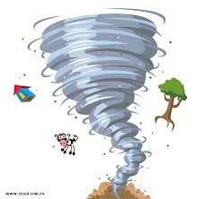
Severe Weather Drill: In preparation for a severe weather event (e.g.; tornado, severe thunder storm, earthquake, etc.). These drills are conducted in November and March of each school year, in conjunction with the National Weather Service, the Fayette County Emergency Management Agency, as directed by the Governor. When the County Severe Weather Alarm system is activated, students and staff move to safe places within the school building and practice assuming a
protected position on the floor. Schools evaluate the speed and
effectiveness of movement to the safe areas and accountability of the
students.

Lockdown Drill: In preparation for an armed intruder threatening the school. These drills are conducted at least once per semester. The Lockdown alarm is activated in order for the school to recognize the alarm. Schools evaluate the quickness and effectiveness of the response of the staff, students and teachers in locking doors, moving students to a safe place,
accountability for students and reporting their status. The school staff evaluates its reaction time and both internal and
external communications.

